OFFICIAL COORDINATION REQUEST FOR
NON-ROUTINE OPERATIONS AND MAINTENANCE

COORDINATION TITLE- 24JDA01 – SFL 2-Fish Turbine Operation and Floating Orifice Gate Removals
COORDINATION DATE- 1/31/24
PROJECT- John Day Dam
RESPONSE DATE- 2/15/2024

Description of the problem - The John Day South (JD-S) fishway has an auxiliary water supply powered by three turbines which feeds water to the entrance area of the JD-S fish ladder. Each turbine design is complex and consists of a turbine, gear box, and the pump itself.
During the 2023 winter maintenance season, metal shavings were found in south fish turbine (SFT) #3 that required major gearbox repairs (as of 1/30/24 repairs are still underway, and repairs are anticipated to be completed by 1 March 2024). Additionally, on 1 March 2023, excessive vibrations, due to worn guide bearings, were noticed at SFT #2 (SFT #1 has a similar issue). To preserve the life of SFT #1&2, personnel opted to run them at reduced RPMs (55 RPMs instead of the usual 68 RPMs) in 2023.
Currently, SFT #1&2 are in the planning phase of major overhauls, therefore acquiring significant funding at this time which is underway.
Two JD-S SFT’s, running at max RPMs (68-RPMs), are required to meet FPP criteria, with one remaining as a back-up. The FPP provides operational guidance for AWS turbine failures. With SFTs #1&2 running at reduced RPMs, SFT #3 (when repairs are completed) will operate at max RPMs, and either SFT #1 or #2 will operate at reduced RPMs (while the other acts as a backup).
The FPP states “if one turbine fails, increase the output of the two remaining turbines to meet adult fishway criteria” (3.2.4.1.a.). Since SFT #3 will already be running at max RPMs and the other SFT can only be run at reduced RPMs, this will not be possible. Therefore, personnel are requesting to operate JD-S in a modified 1-turbine operation (3.2.4.1.b). All entrance weirs will be open at 8’ (instead of closing NE-1), and the floating submerged orifice gates (FOGs) will be closed. This should allow for adequate attraction flow to the JD-S while also leaving one SFT available for backup.

Type of outage required – FOGs will be removed for 2024 similar to the 2023 adult passage season. The additional water savings will aid in decreasing the output of SFT 1 or 2 and will help by decreasing any degradation to the unit’s pump assemblies, which are in poor shape and at risk of total failure.

Impact on facility operation – There will be minimal impacts to facility operation. However, removing the FOGs will allow the remaining JD-S entrances to run in criteria while also freeing up one of the turbines as a backup.

Dates of impacts/repairs – 1 March 2024 – 11 November 2024

Length of time for repairs – Unknown, as stated earlier SFT #1 & #2 are in the planning phase of a major overhaul with no set repair dates.

Analysis of potential impacts to fish-
None- Mean travel time for Spring migrants was similar between 2022 and 2023.

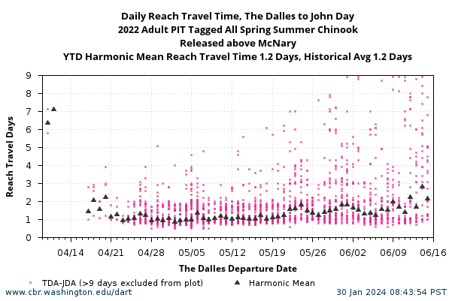

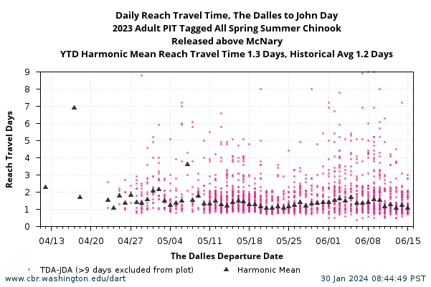

Summary statement – expected impacts on:

Downstream migrants: There is no expected impact to downstream migrants.

Upstream migrants (including Bull Trout): The entrance weirs and their entrances will be kept in FPP ranges.

Lamprey: The entrance weirs and their entrances will be kept in FPP ranges.

The condition of South fish turbine pumps 1 & 2 gives the project no flexibility in maintaining entrance criteria at the ladder entrances if the floating orifices are redeployed.

Comments from agencies

Final coordination results

Please email or call with questions or concerns.
Thank you,

Eric Grosvenor
Supervisory Fish Biologist
Eric.Grosvenor@usace.army.mil

Patricia Madson
Columbia River Coordinator (acting)
patricia.l.madson@usace.army.mil

